**Family Sharing App: Receive a Name**

**Major Changes Since Last Version**

Changed specification for header and footer size. The purpose for doing this is to give more space to the reserve button, so users do not accidentally hit the next tab.

I equalized the header and footer size to give the layout continuity.

Only these changes are stated in this revision of the specification

**Executive Summary**

The Family Sharing app makes sharing ancestors’ temple work fun and easy. The user simply selects what ancestors they want, and the user is prepared to do the work for those ancestors.

**Detailed Design**

**Shared Ancestors View**

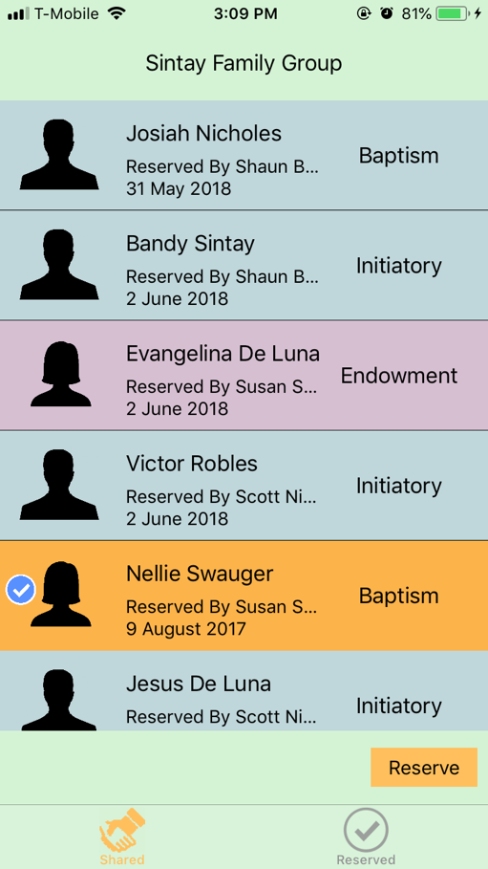

**Action List View**

